**Objective: To design and implement a multi-region disaster recovery solution using AWS services, where infrastructure is deployed in two AWS regions. The solution will replicate data across regions, ensure high availability, and implement a failover mechanism for disaster recovery. The project involves using Terraform to provision infrastructure.**

**Services used:**

* **Amazon VPC**
* **Amazon S3**
* **Amazon RDS**
* **Amazon route 53**
* **Terraform**
* For this project we have to create module folders for VPC, Load balancer, EC2 instances, RDS, S3 for storing state files also another s3 for storing the image going to upload in our webpage.

**Note: In each module folder we will be having Terraform Configuration block, specifically the required_provider block. It tells Terraform which providers our configuration depends on, and optionally which versions to use. Terraform uses providers to interact with cloud platforms and other services — like AWS**, **Azure**, **Kubernetes**, **GitHub, etc.**

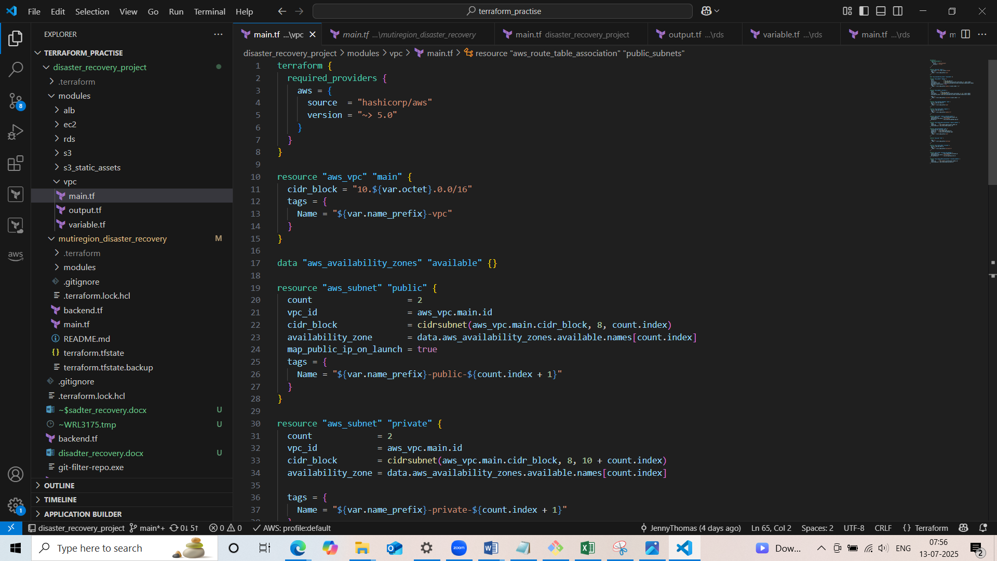

* **In each module subfolder we will have main.tf ,variables.tf and output.tf files.**
* main.tf is the **primary Terraform configuration file**. It contains the actual **resource definitions** that describe what infrastructure to create.
* variables.tf defines **input variables** used in main.tf or other .tf files. These allow your configuration to be **parameterized** and reusable.
* outputs.tf defines **output values** that Terraform will show after apply. These are useful for referencing resource attributes or passing values between modules.
* Our first module subfolder is vpc which consists of the following resources creation(main.tf):
* A VPC with cidr block
* Two public subnets in different availability zone for EC2 instances
* Two private subnets in different availability zone for RDS
* An internet gateway for accessing internet
* Route table for public subnets and route to internet via internet gateway
* Route table association of public subnets
* NAT Gateway for the accessing internet for the private subnets(NAT Gateway will be created in public subnets)
* Route table for private subnets and route to the internet via NAT Gateway
* Route table association of the private subnets

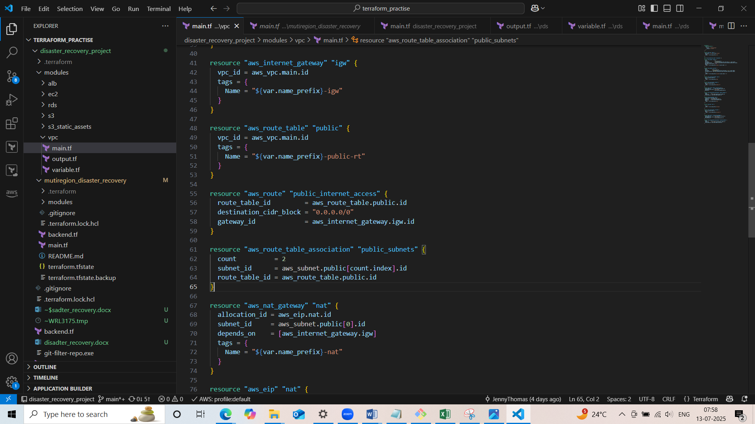

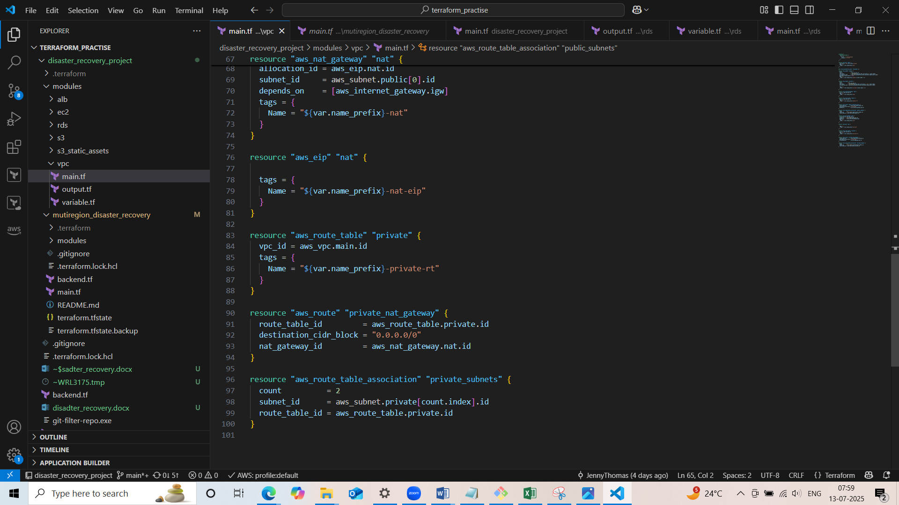

* Defined input variables in variable.tf for name_prefix,region and octet which we used in main.tf

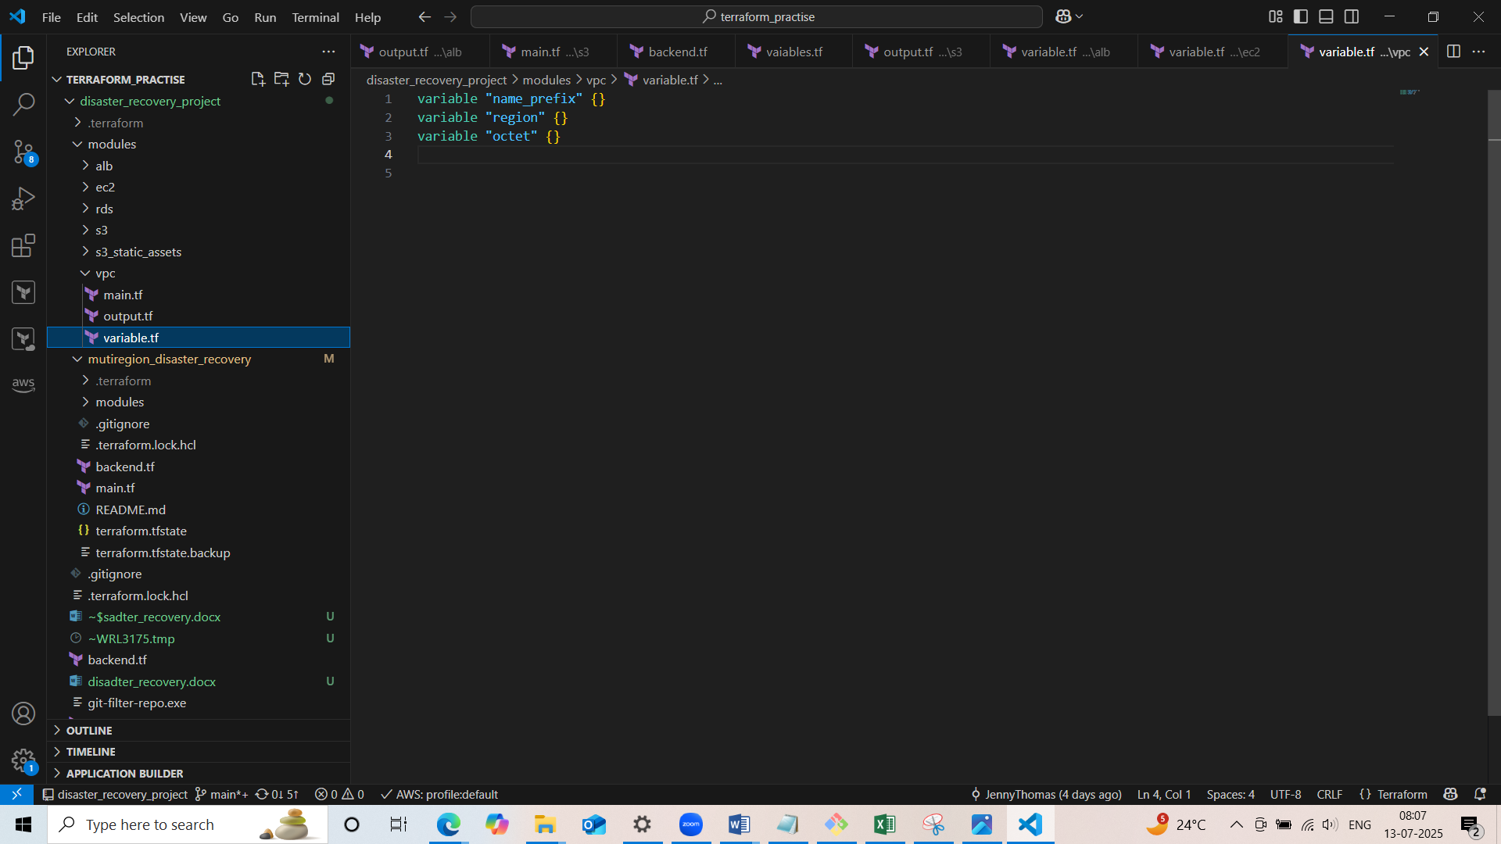

* In output.tf will define the output values for vpc id, public subnets id and private subnets id.

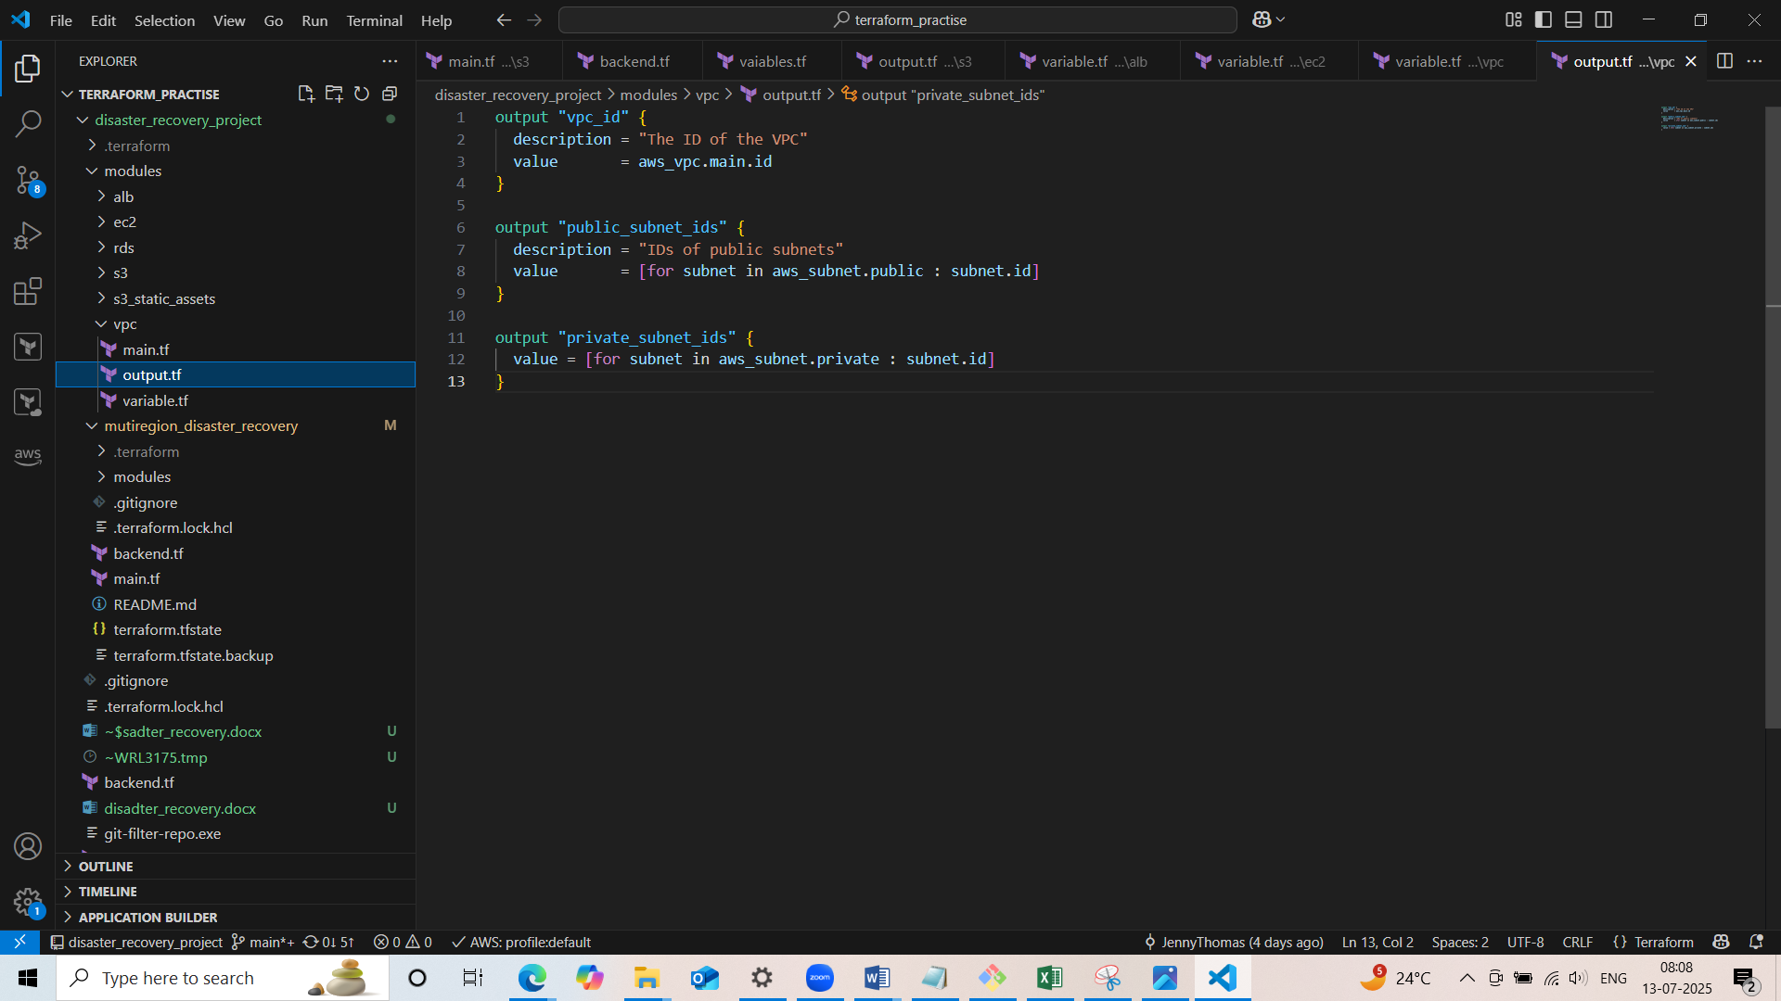

* Our next module subfolder is alb for load balancer which consist resource creation of: (main.tf)
* Security group for load balancer which allow inbound HTTP rule and outbouns rule which allows the internet access.
* A application load balancer
* A target group
* A listener which associated with load balancer which forwards traffic to target group

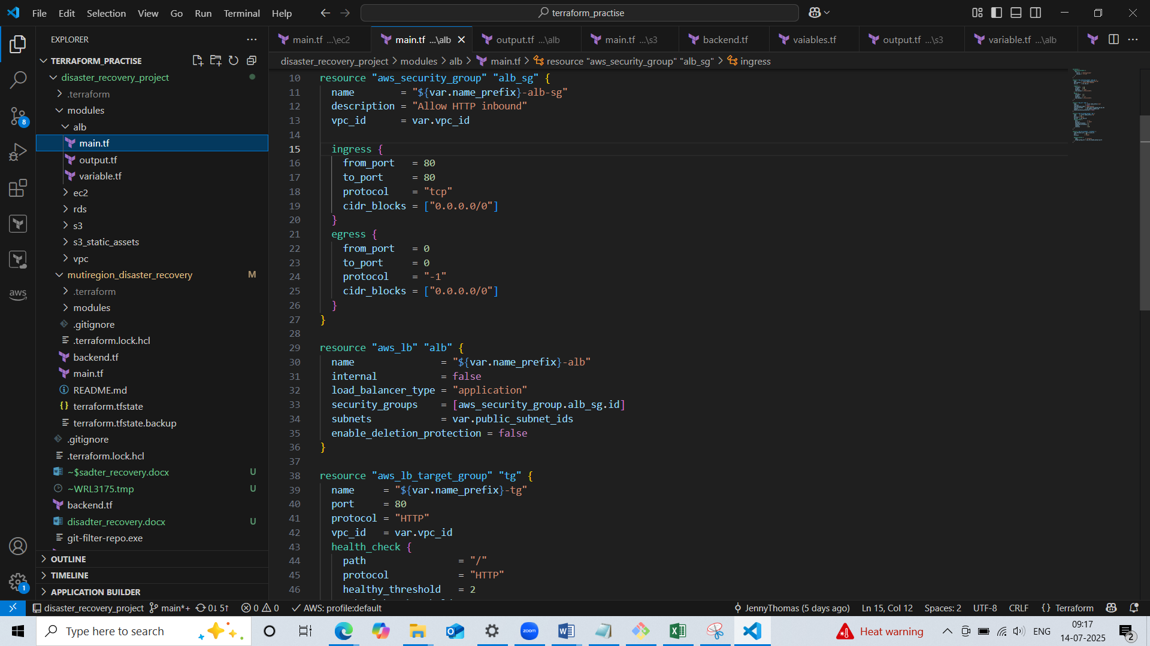

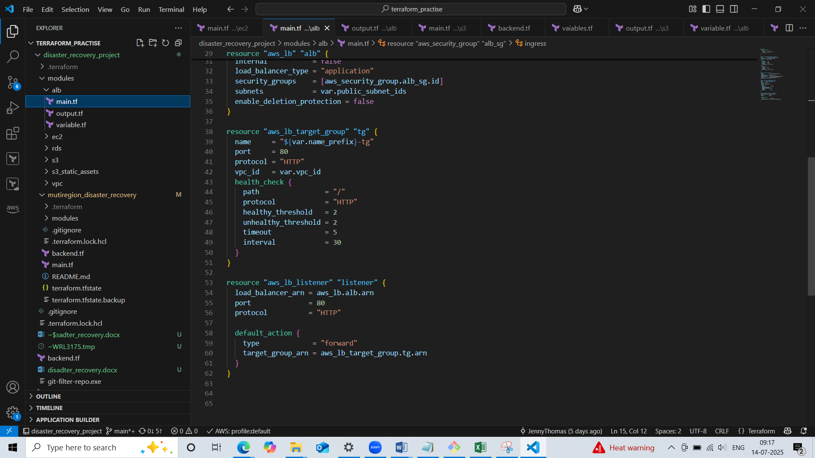

* Defined input variables in variabls.tf for vpc id, name prefix, public subnet ids

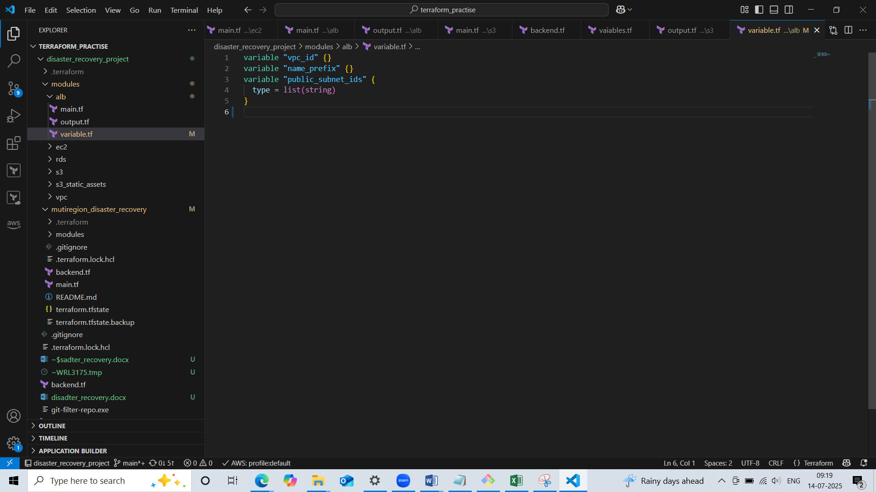

* Define output values in output.tf for target group arn

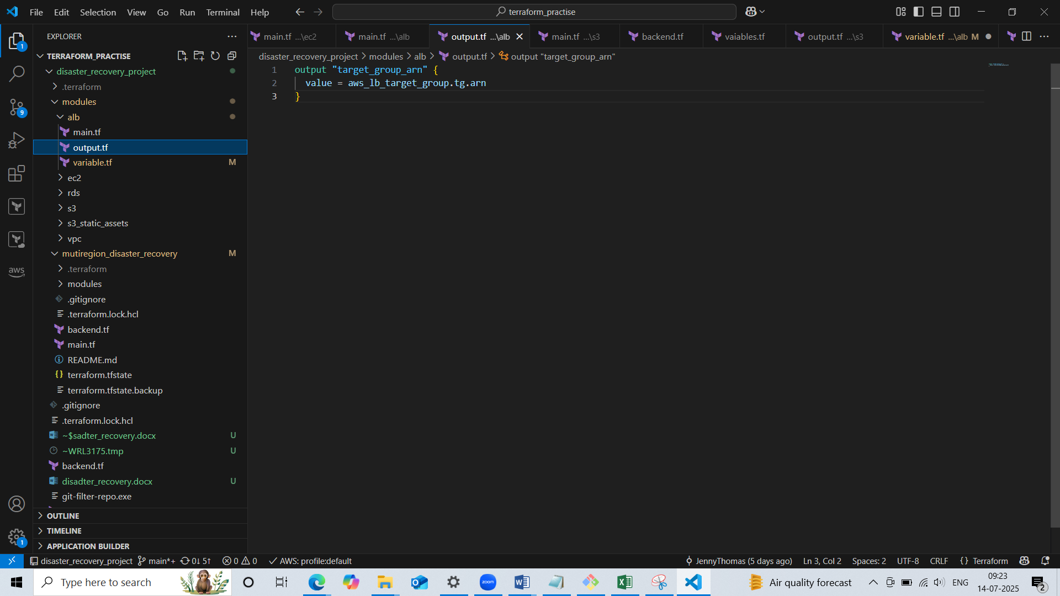

* Our next module subfolder is ec2 which consists resource creation of:
* Security group with inblound rule which allows HTTP and SSH connection, and outbound rule which allows to internet.
* A launch template for ec2 with userdata
* An auto-scaling group

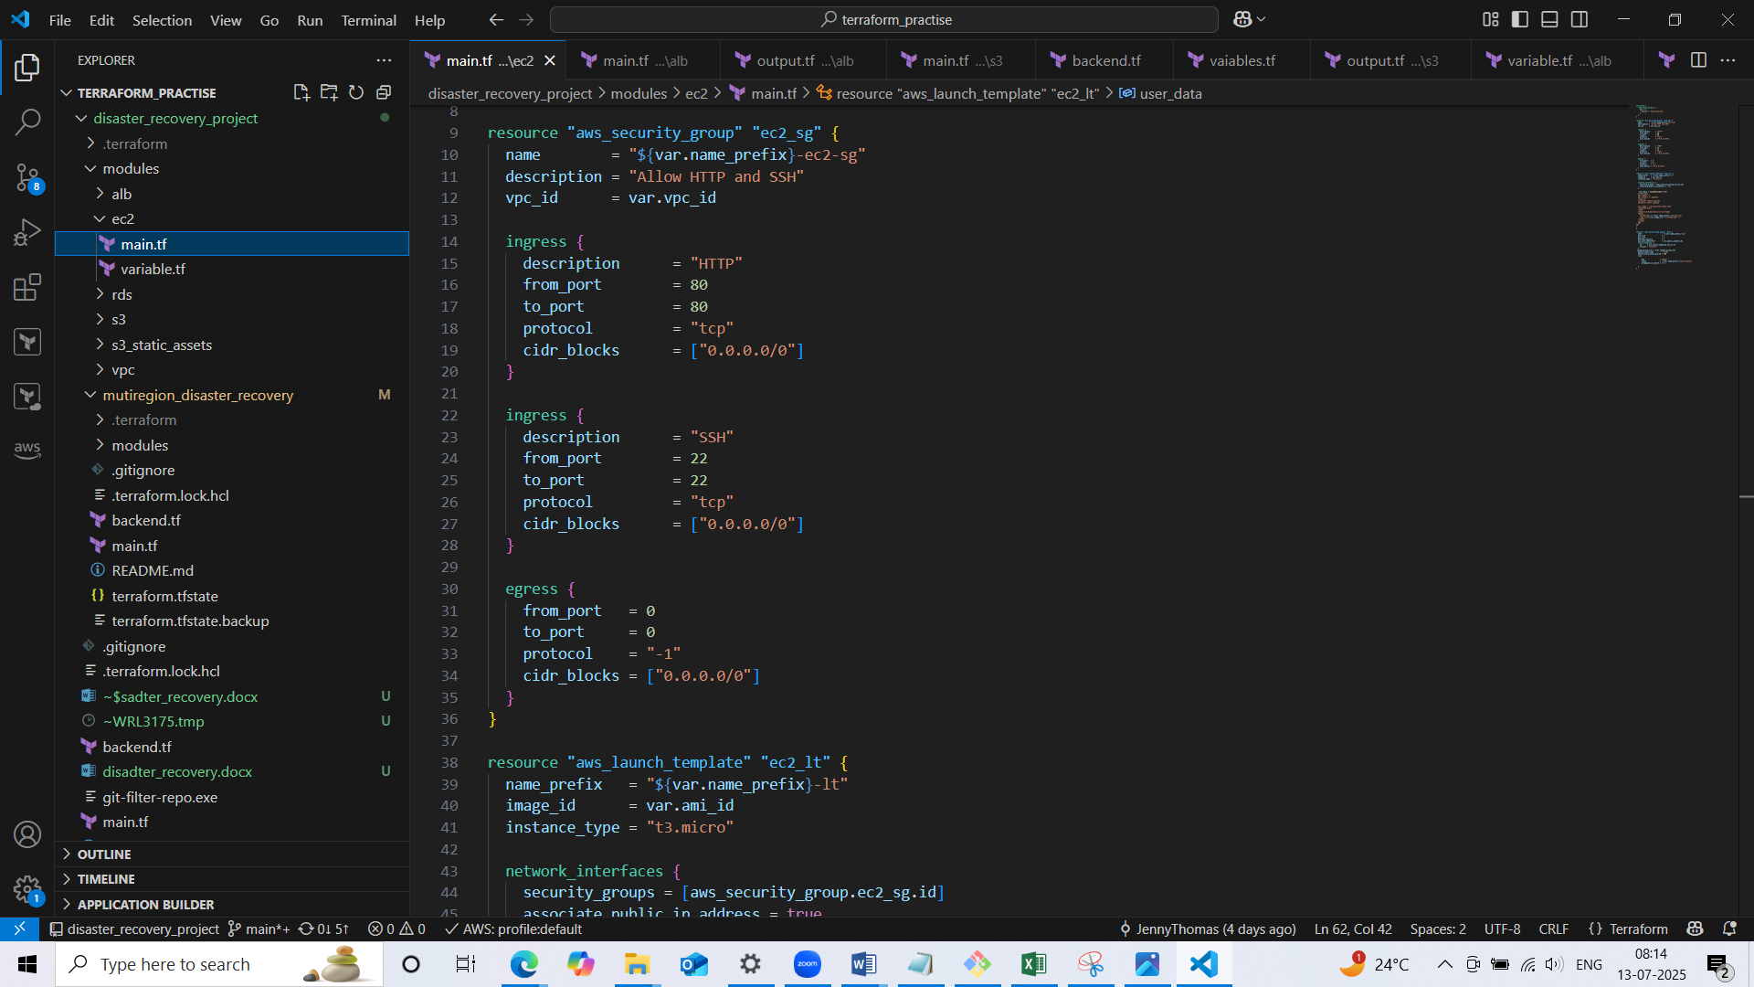

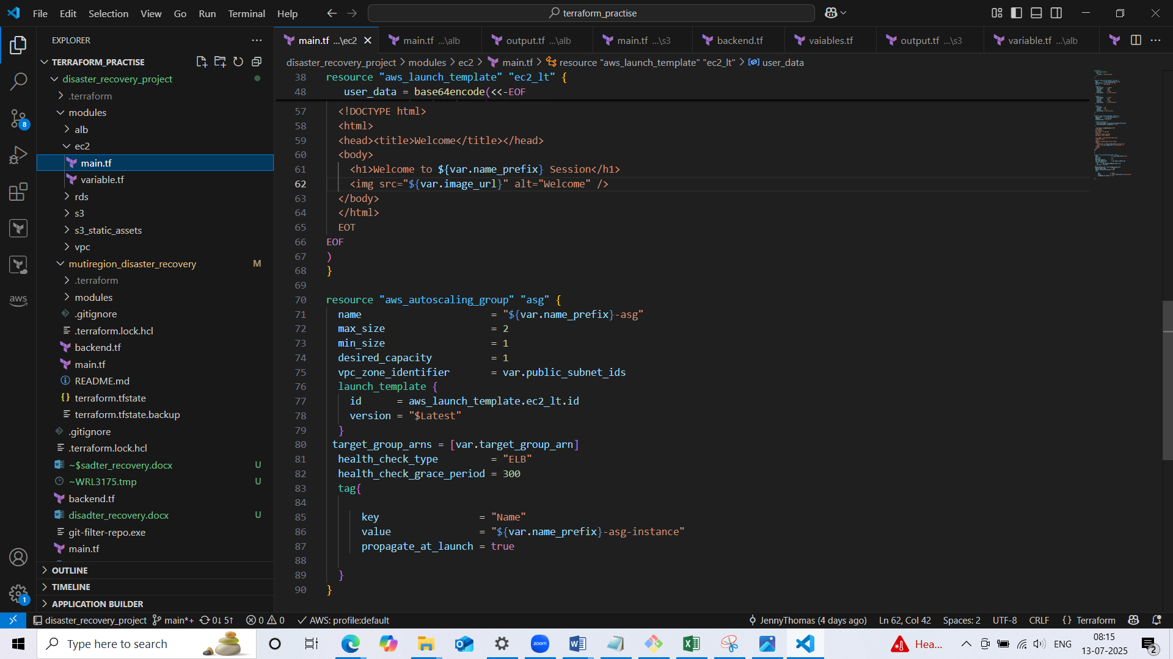

* Define input variables in variable.tf for vpc id, name prefix, target group arn and image url which used in userdata(image will be stored in s3)

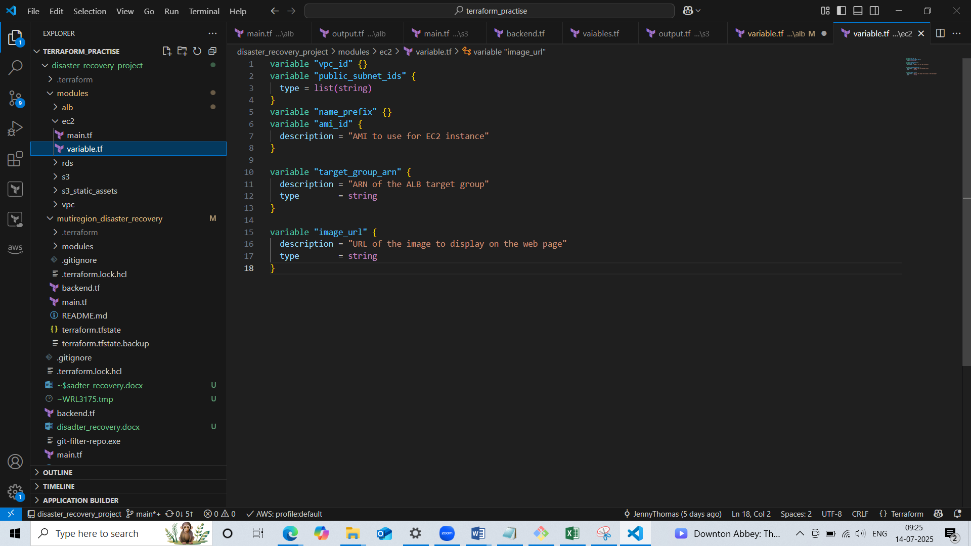

* Our next module subfolder is s3 which consists resource creation of:
* Random string that 3 bytes long to generate a unique suffix
* An AWS s3 bucket
* AWS bucket ownership controls that ensures the bucket **enforces ownership** of all uploaded objects, regardless of who uploads them. All objects are owned by the bucket owner required for some security setups and replication
* Blocks **all forms of public access** to your S3 bucket. It Prevents accidentally making the bucket or any object publicly readable
* Enables **versioning** on your S3 bucket. It allows storing **multiple versions** of the same object required for replication and useful for data recovery.
* Creates an **IAM role** that S3 can assume to perform replication.
* Attaches a policy to the replication role to give it permission to Attaches a policy to the replication role to give it permission to and write replicated objects to the **destination bucket**
* Enables **replication from the source bucket to a destination bucket.**

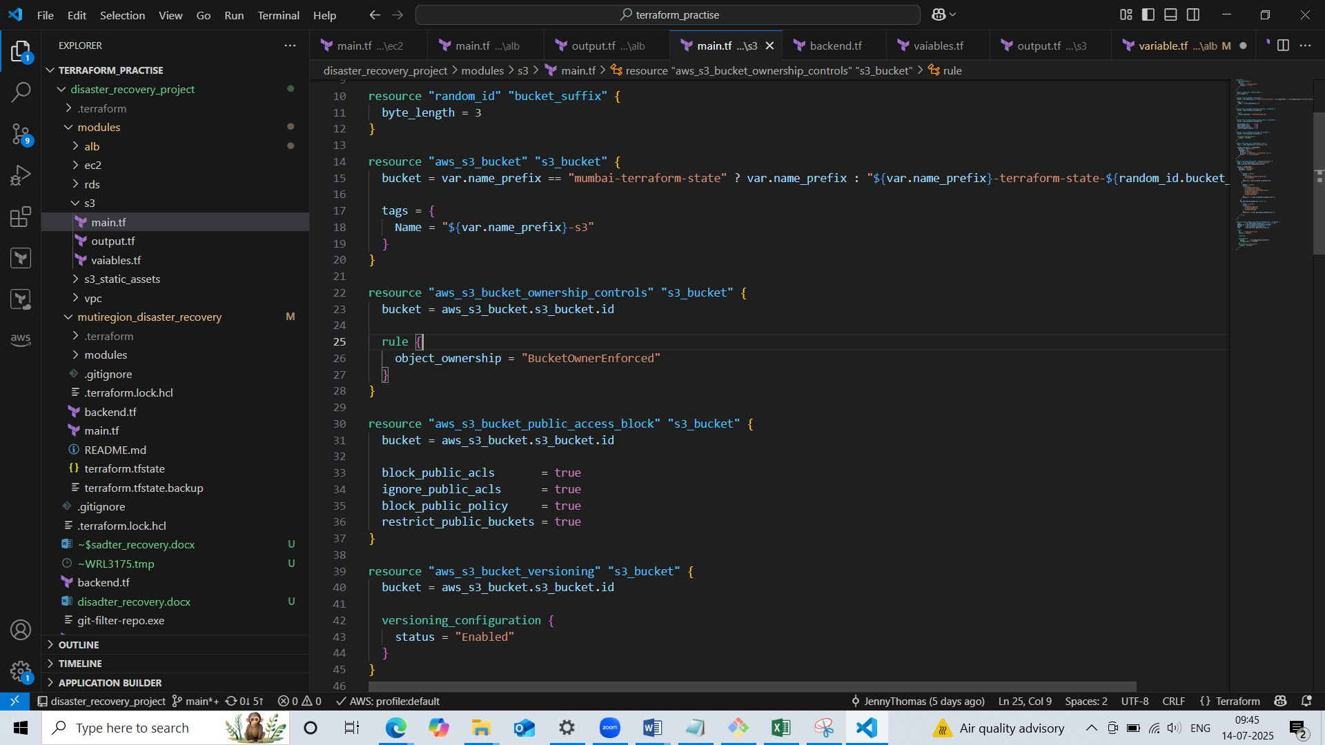

* Defined input variables in variable.tf for name prefix, region, destination bucket arn.

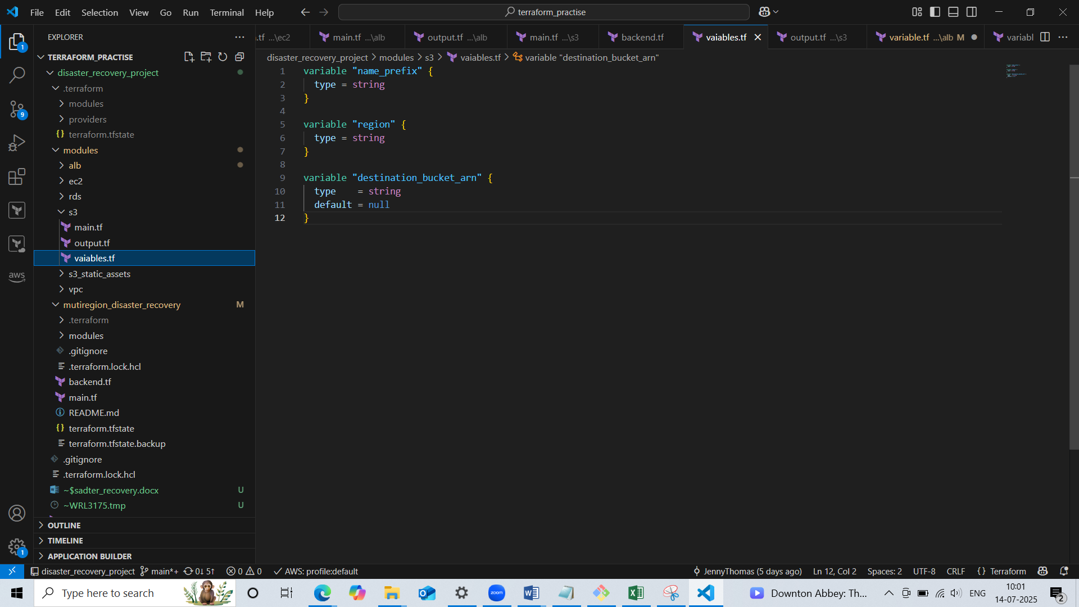

* Defined output variables in output.tf for bucket name

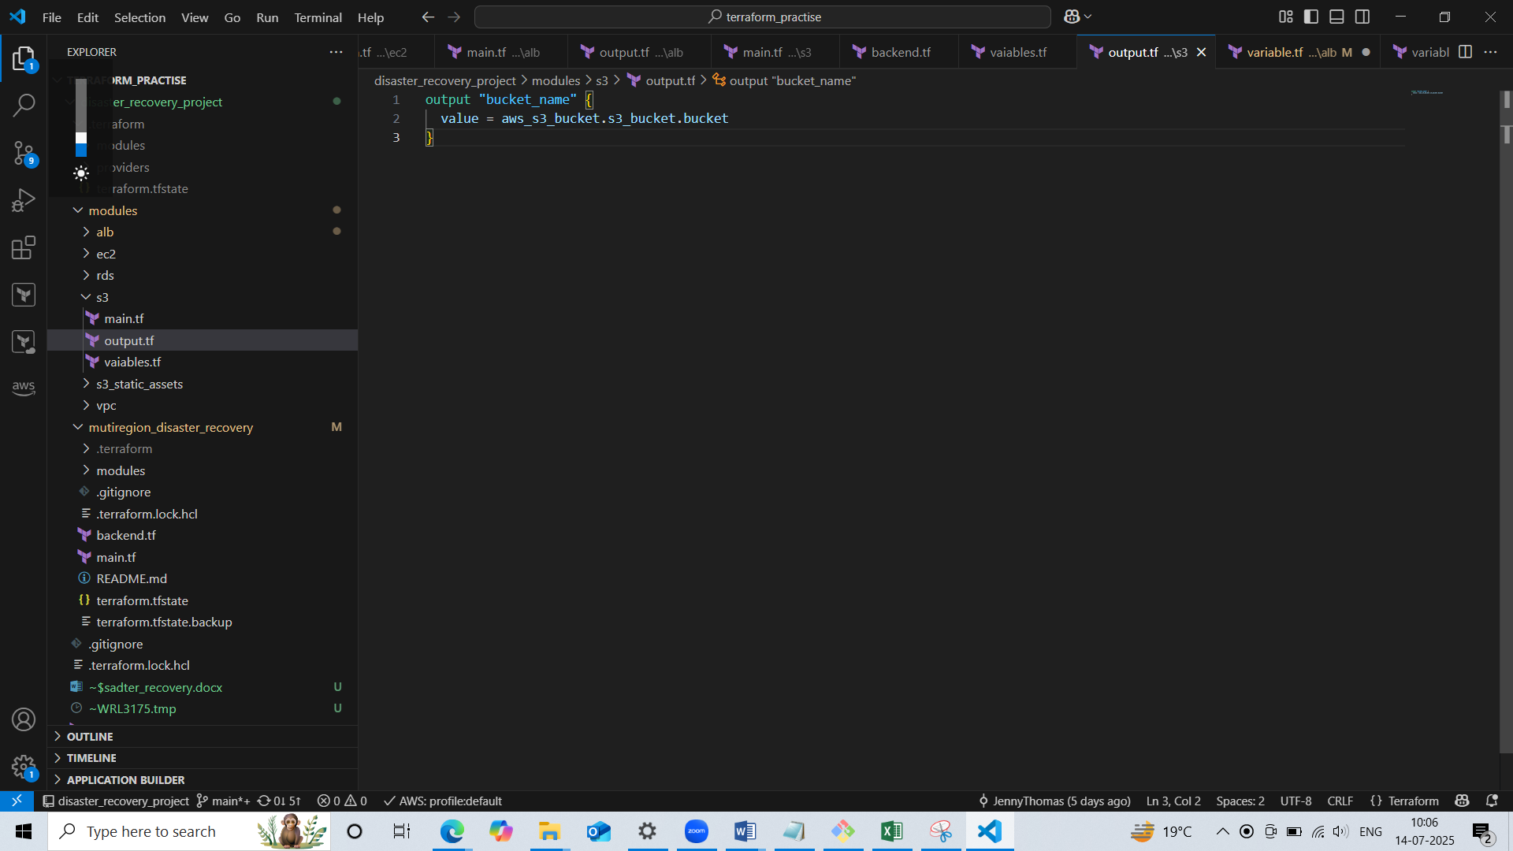

* Next we created a terraform backend block which clearly defines working of our previous s3 bucket that is we are storing terraform state files in S3 bucket of primary region(mumbai) and replicate the data to the secondary region(tokyo).

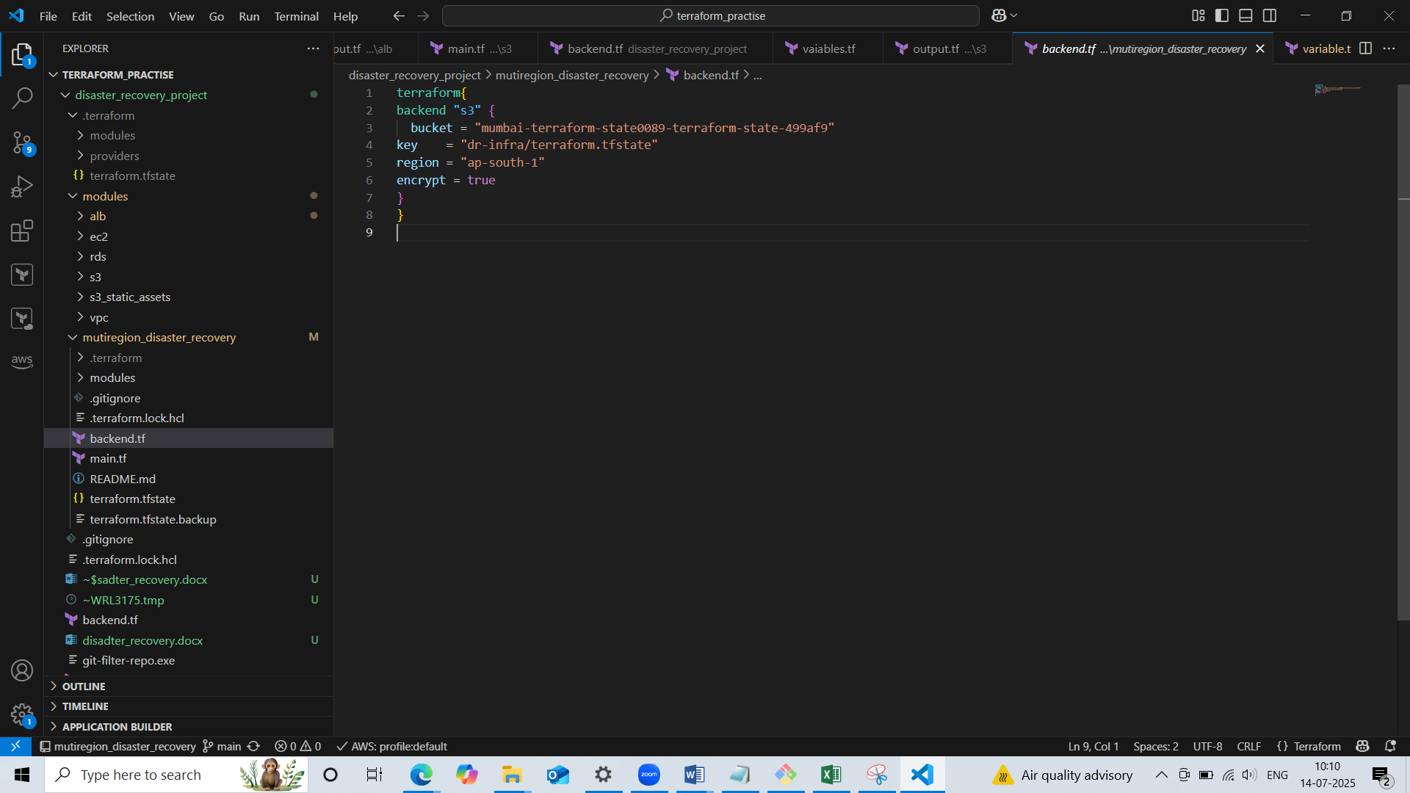

* Our next module subfolder is s3_static_assets which is using to storing the image. In main.tf we created the resources which are:
* An s3 bucket
* Disabling pubic access blockage since we need to upload image
* Allows public read which **all objects in the bucket publicly readable.**
* uploads the local file myland.jpg from your Terraform module folder into the S3 bucket

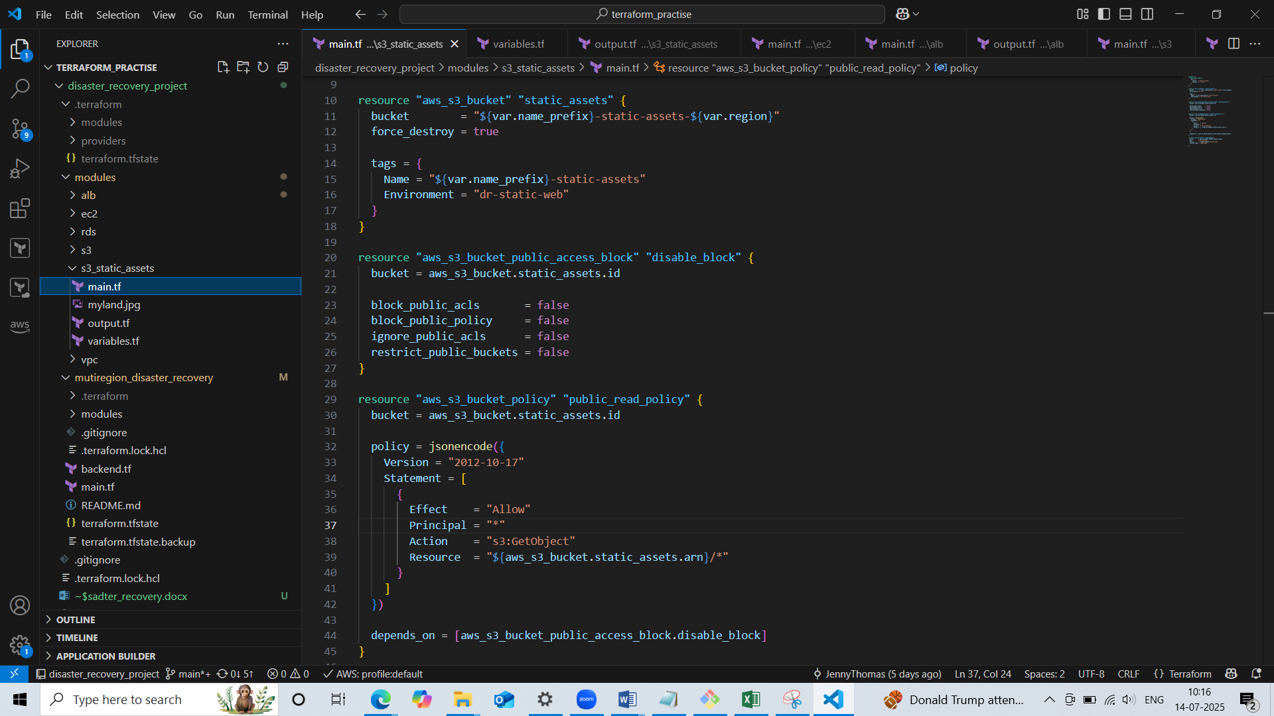

* Defined input variables in variable.tf for name prefix and region

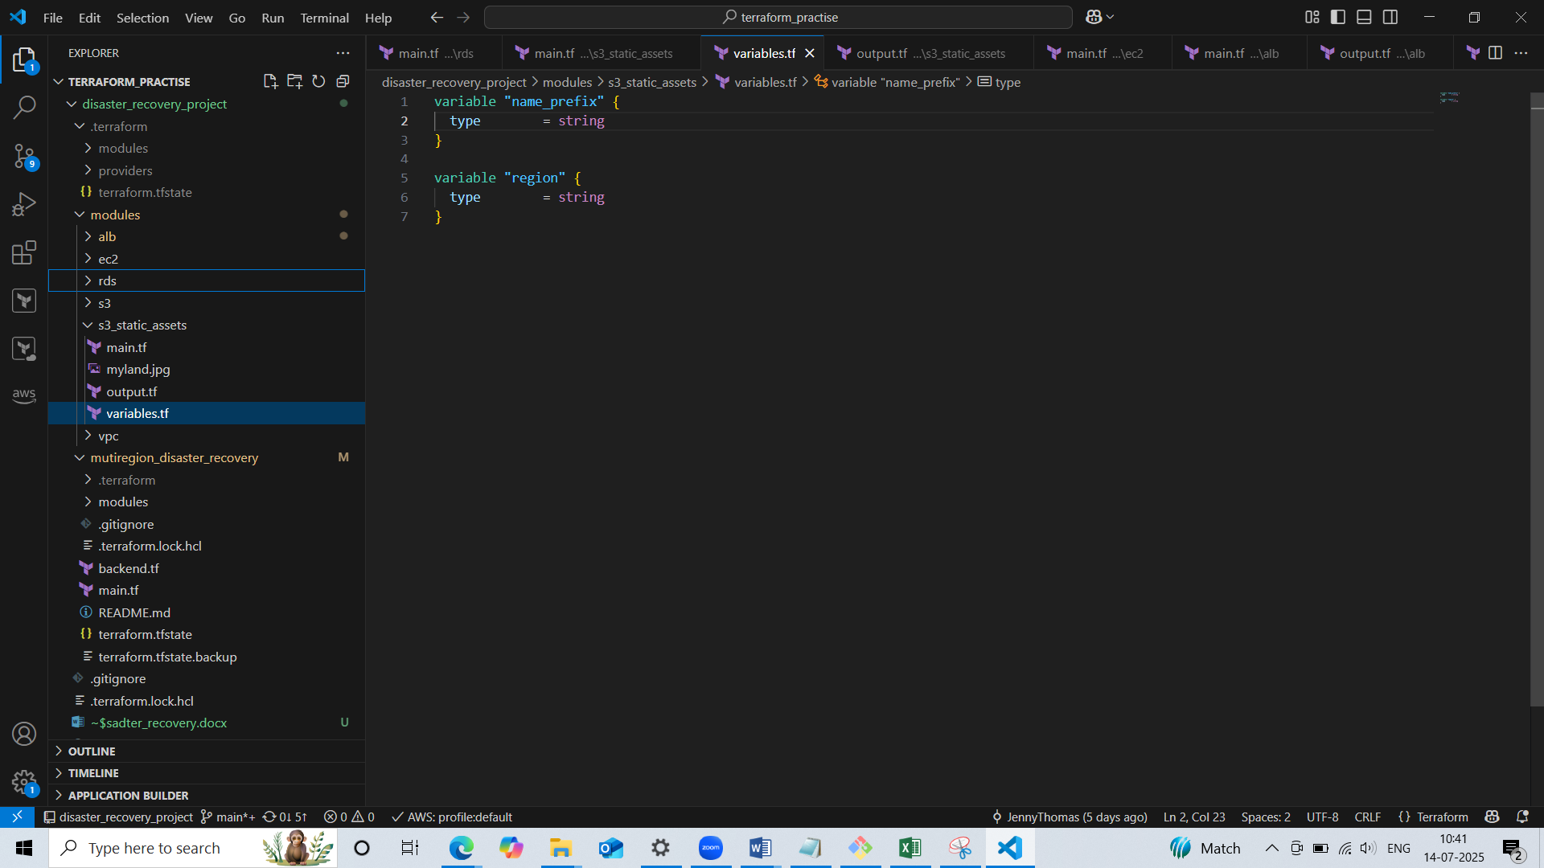

* Defined output variable in output.tf for bucket name and image url

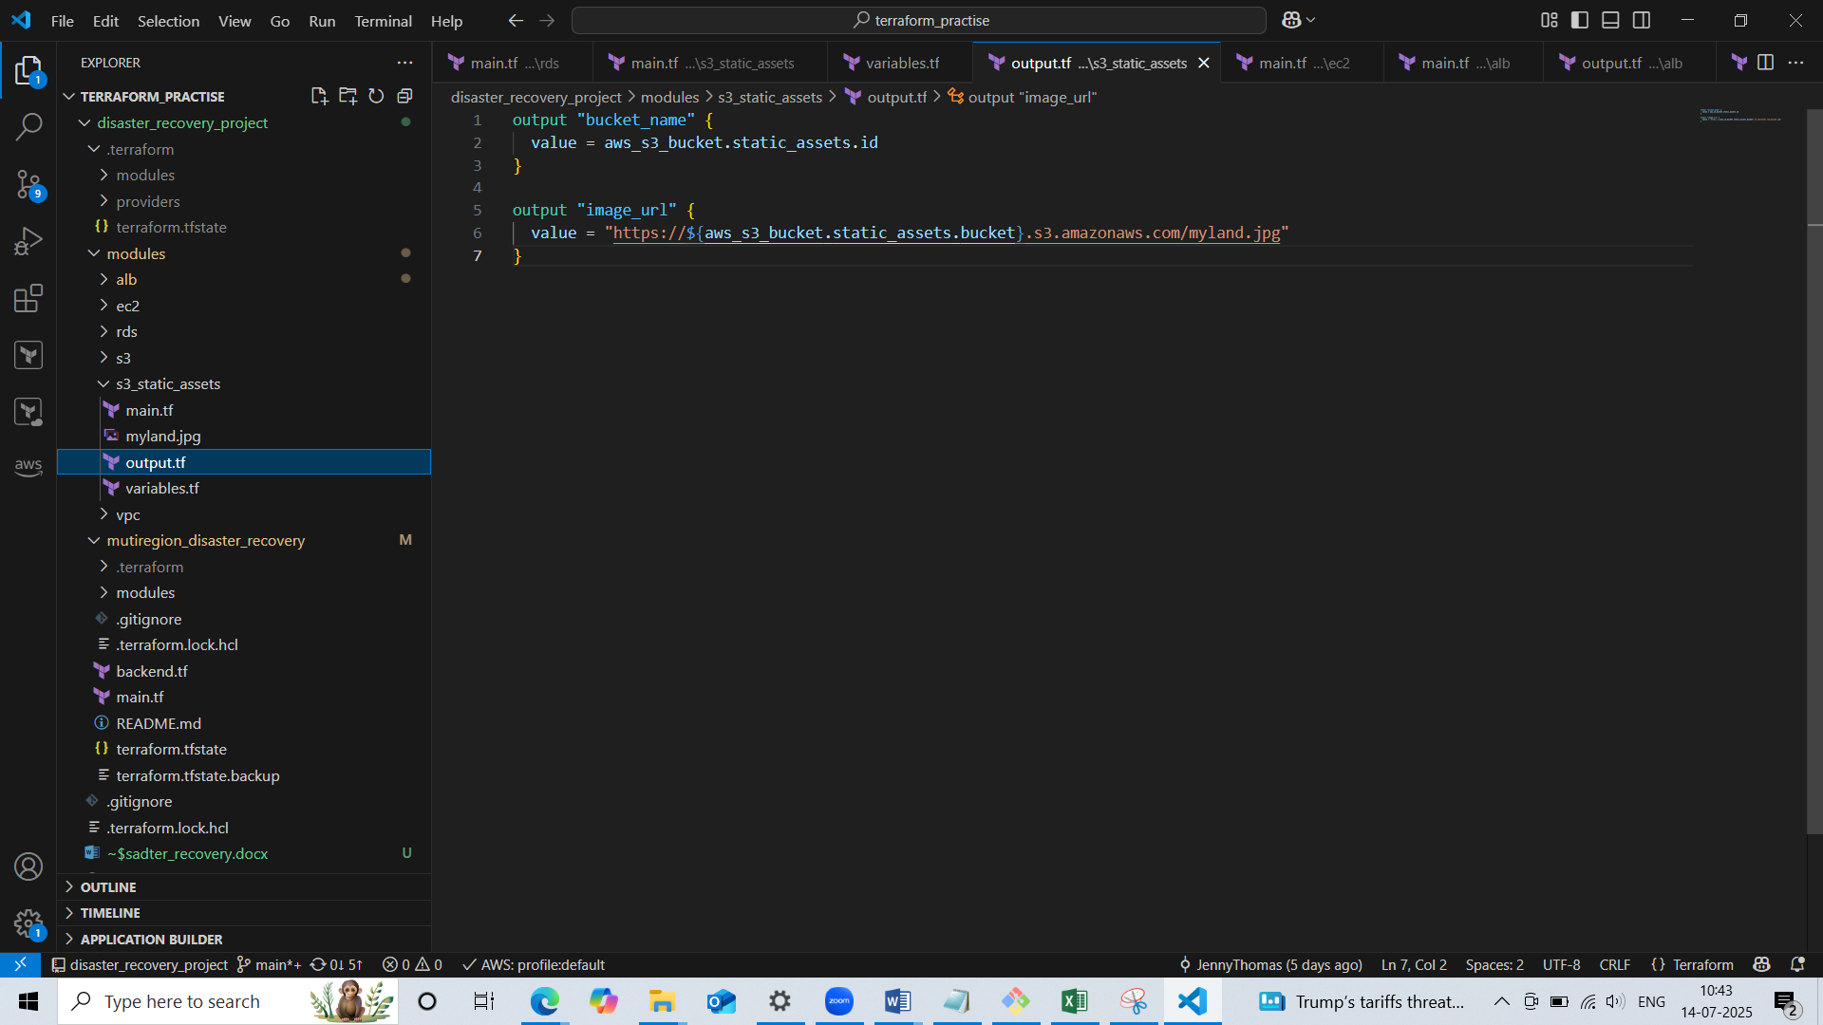

* Our next module subfolder is rds which consists of the resource creation of(main.tf):
* Creates AWS subnet groups and defines where RDS can be placed. We grouped our private subnets to create RDS subnet group. RDS must run in **at least 2 subnets** (in different AZs), so this subnet group tells AWS **where** to place the database.
* Created a RDS instance

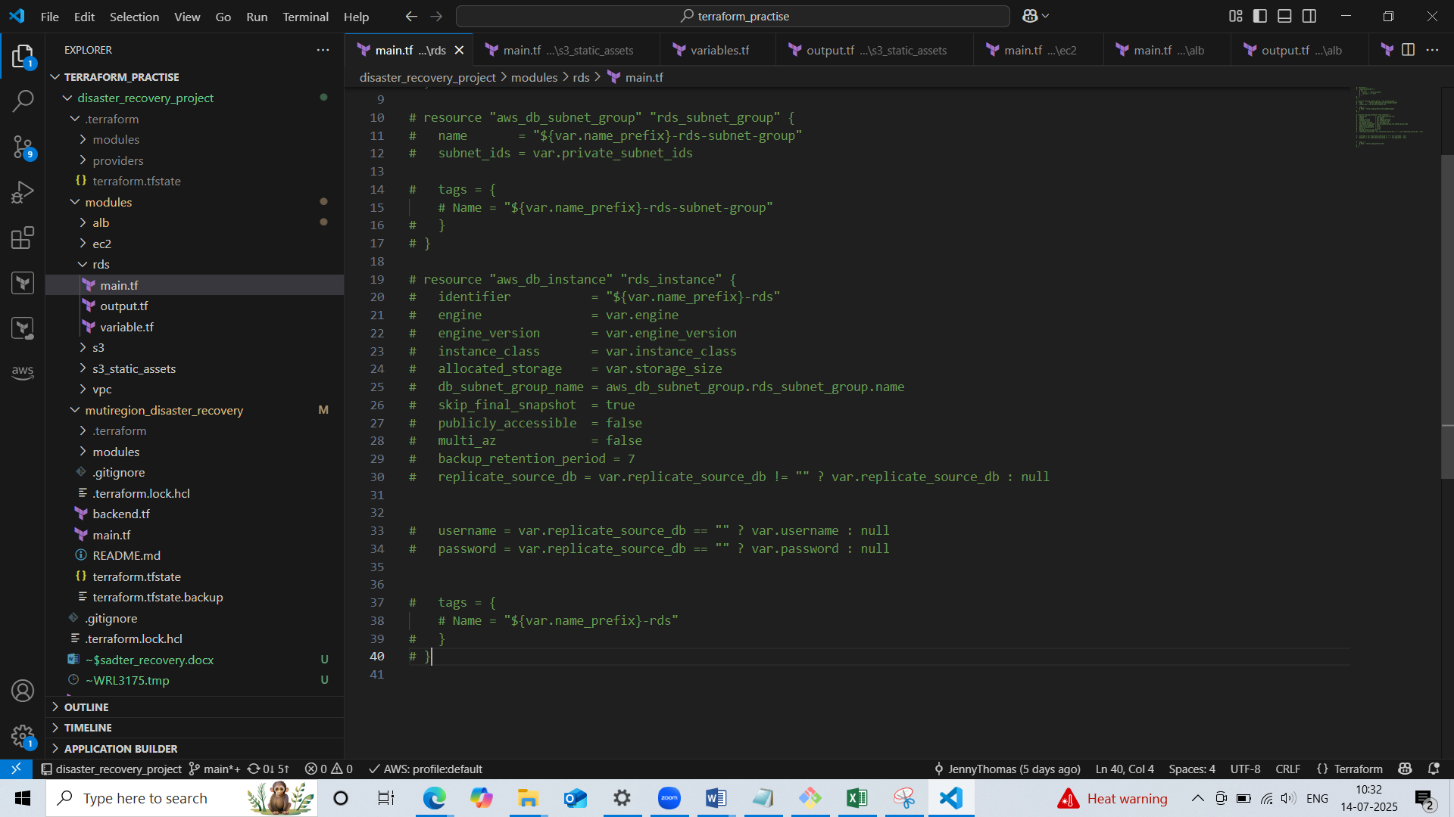

* Defined input variables in variable.tf for name prefix, private subnet ids, engine, engine version, instance class, storage size, username, password and replication source db

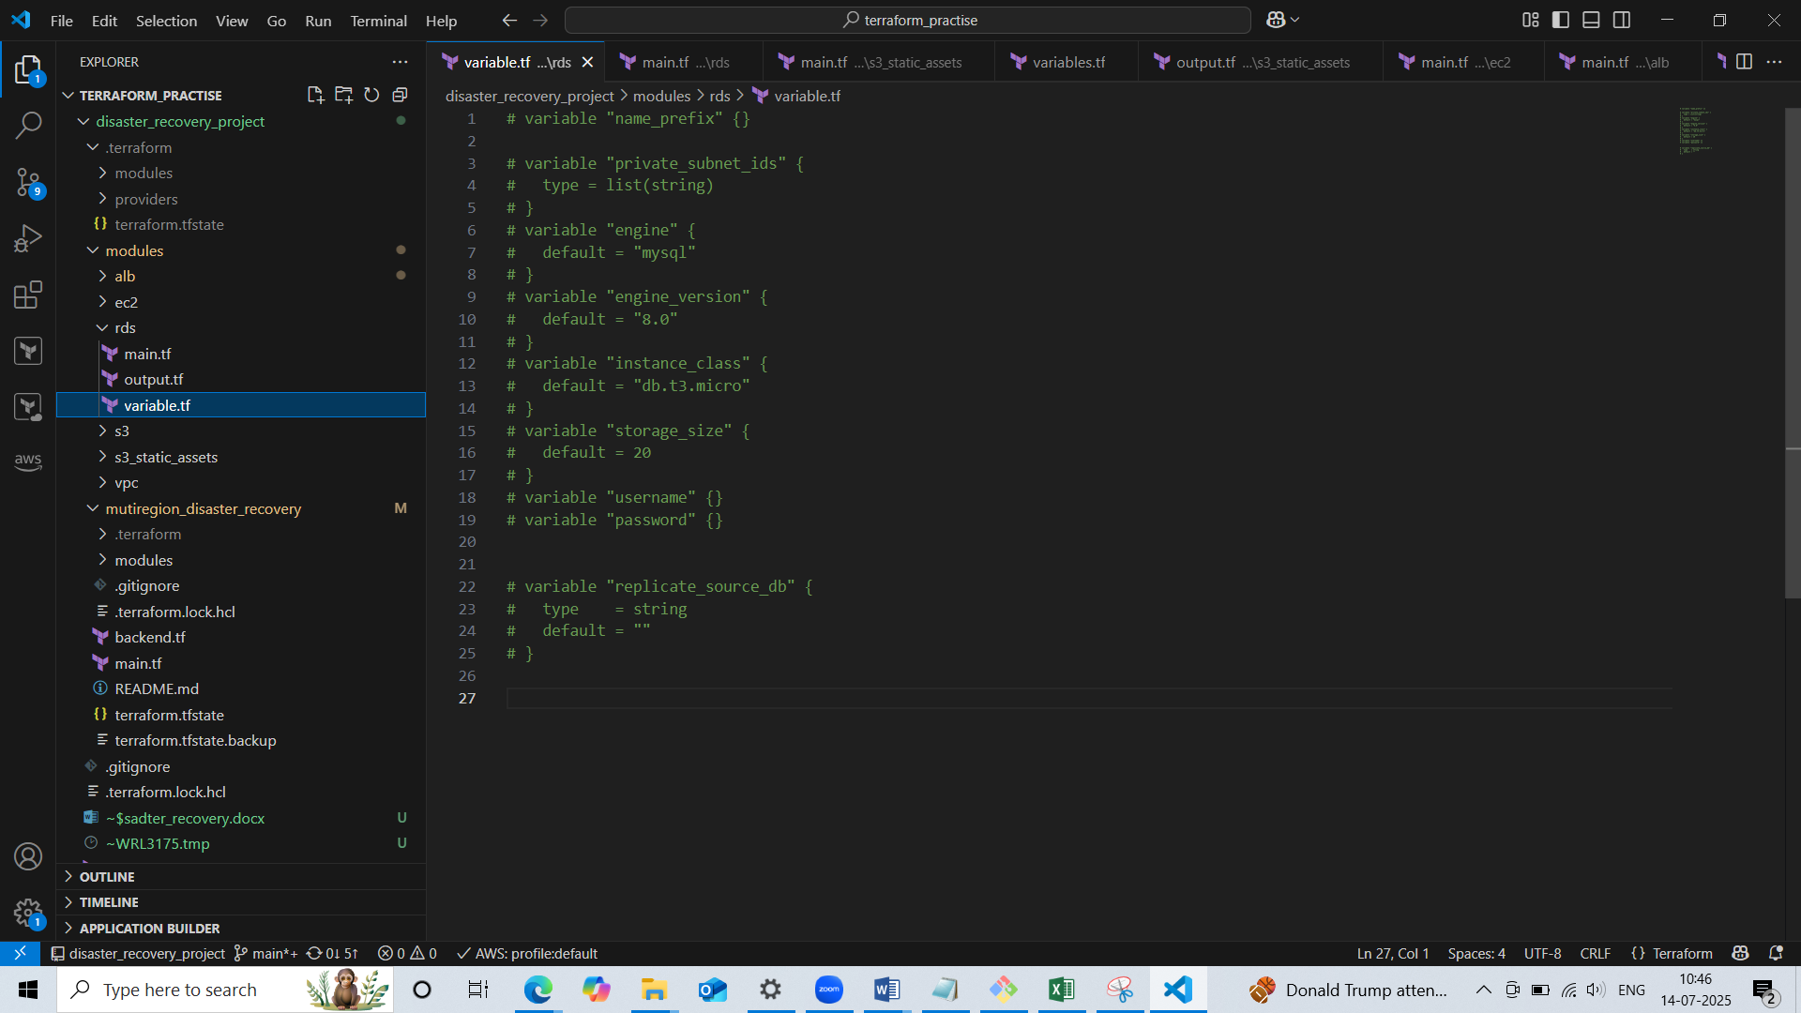

* Defined output values in output.tf for rds instance arn and rds endpoints

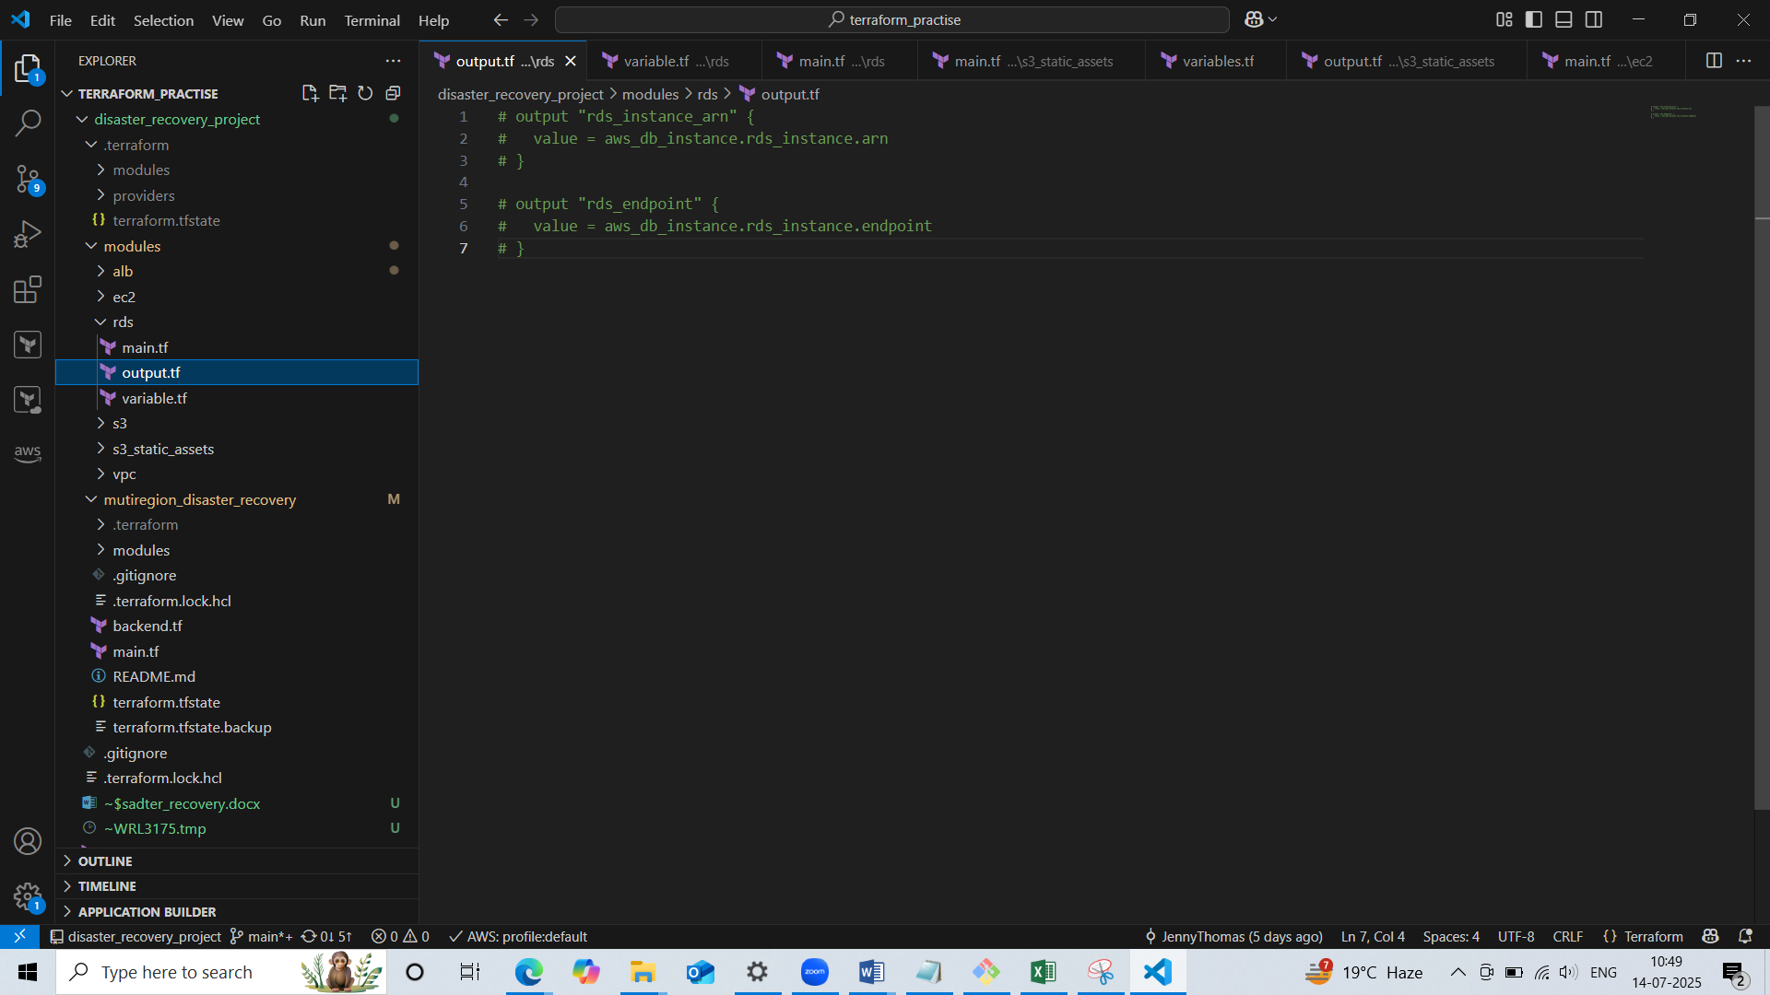

* Now our block is to create root main.tf where we are calling our module subfoders. We are calling the resources in modules which enables the reusability of codes.
* We are having provider block which defined two named AWS provider using alias which point to Mumbai region(primary) and Tokyo region (secondary)
* Calls a reusable VPC module in the Mumbai region and Tokyo region
* Created ec2 instance in Mumbai and Tokyo region and placed it in the public subnets of corresponding region of VPC
* Attack instance to load balancer target group
* Creates application load balancer in both the region
* Creates s3 bucket in Mumbai region and used the destination bucket arn(tokyo) for cross replication
* Creates s3 bucket in Tokyo region and fetches the arn for use in mumbai
* Upload image and make them public via bucket policy and output the image URL for use in your EC2 web apps
* Creates a **primary** RDS instance in private subnets with credentials provided
* Creates a **read replica** of the Mumbai RDS

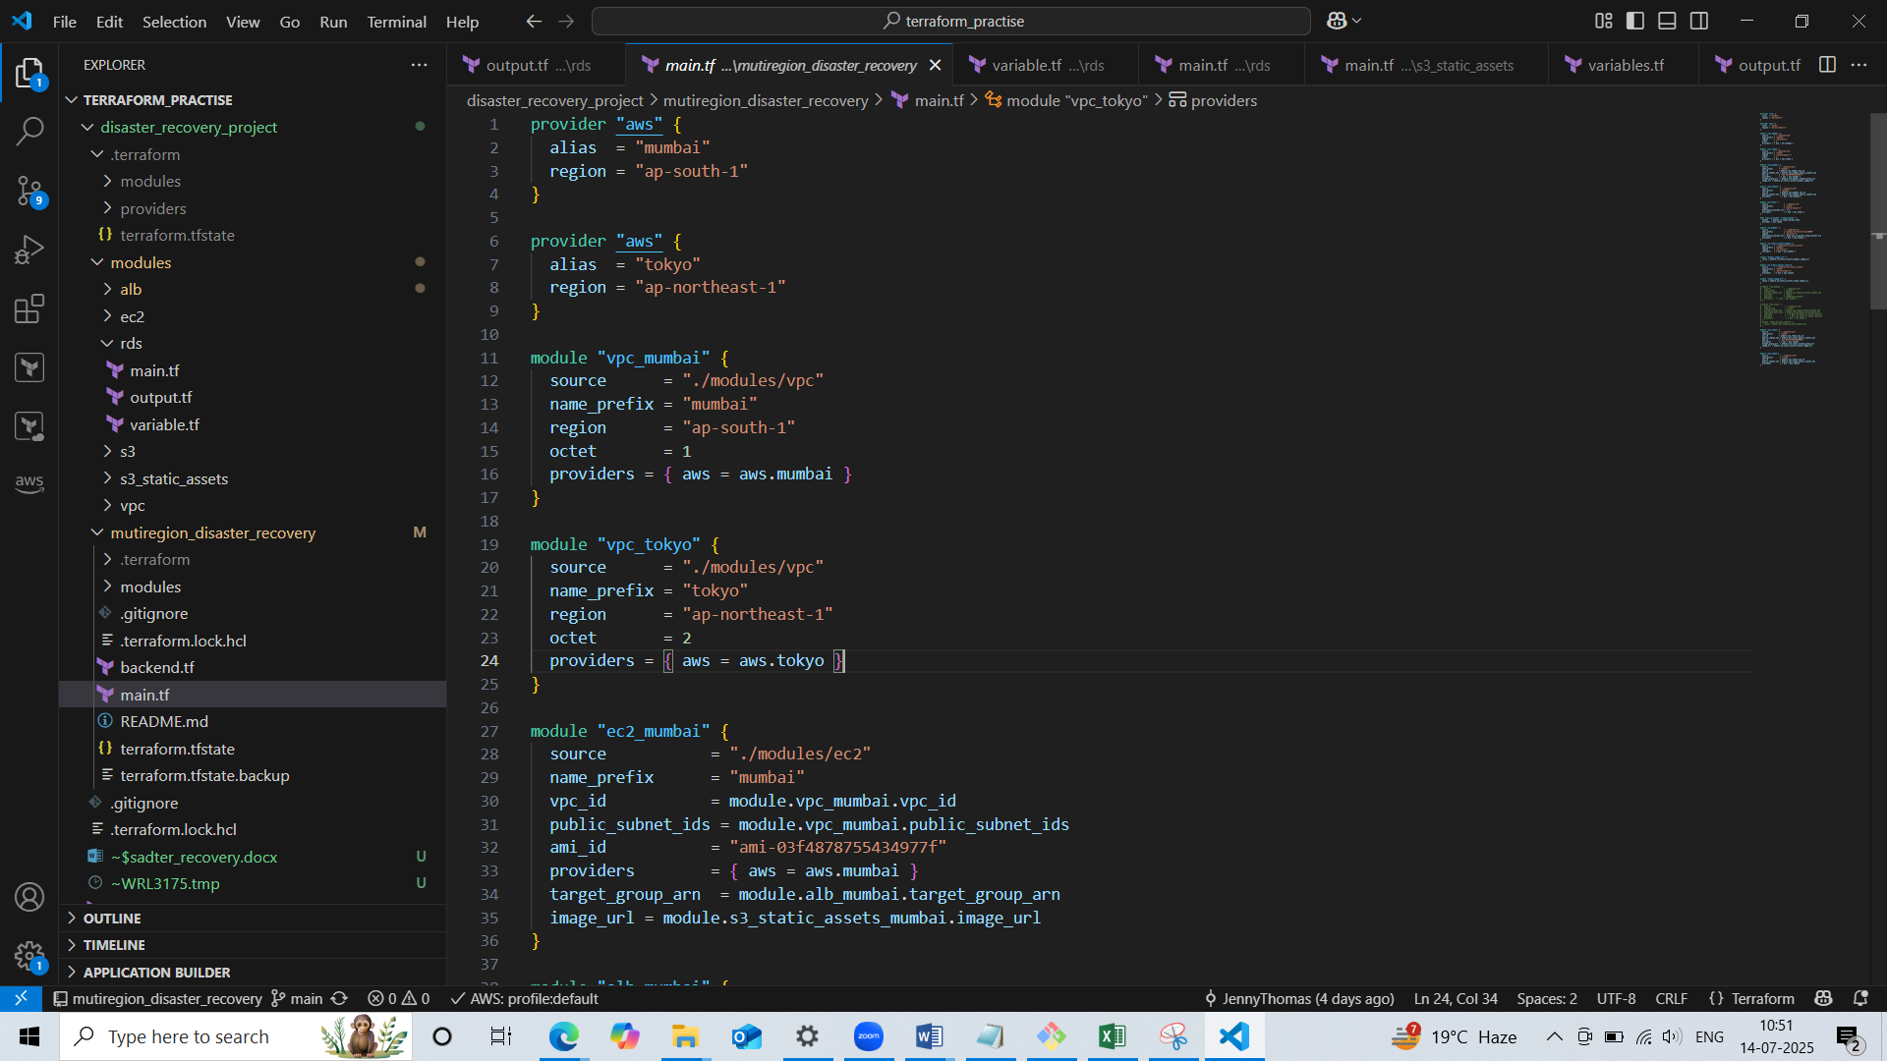

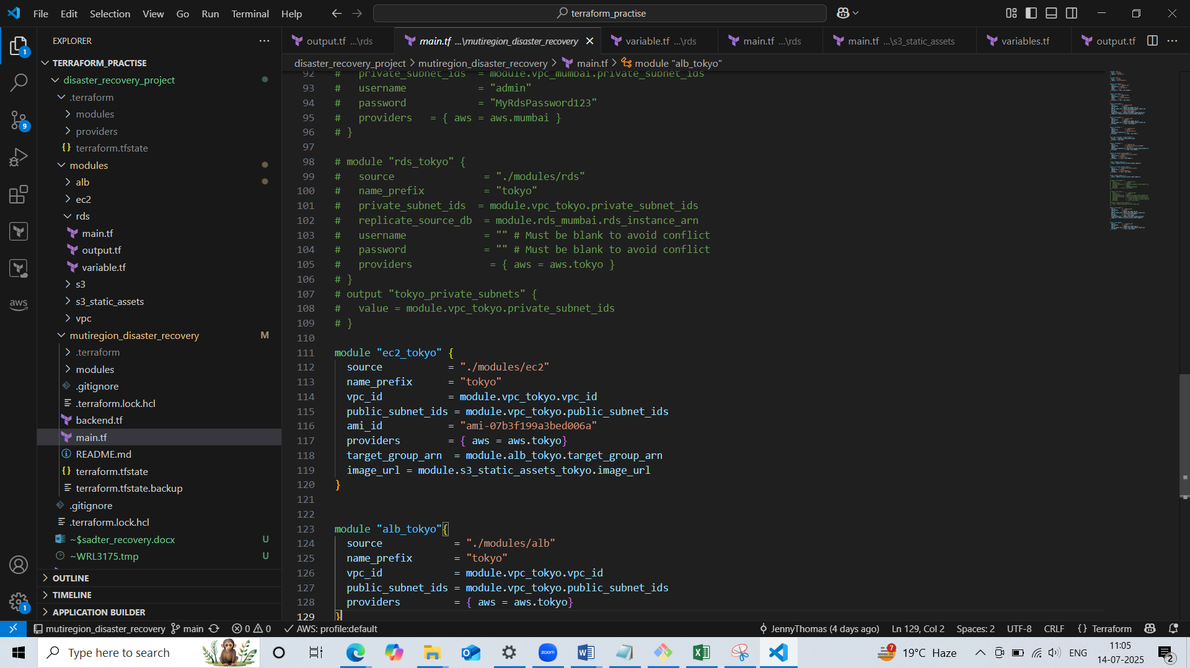

Now code for our terraform structure is ready. For provisioning the infrastructure we have to run the following commands:

* terraform init: terraform init initializes your Terraform **working directory**

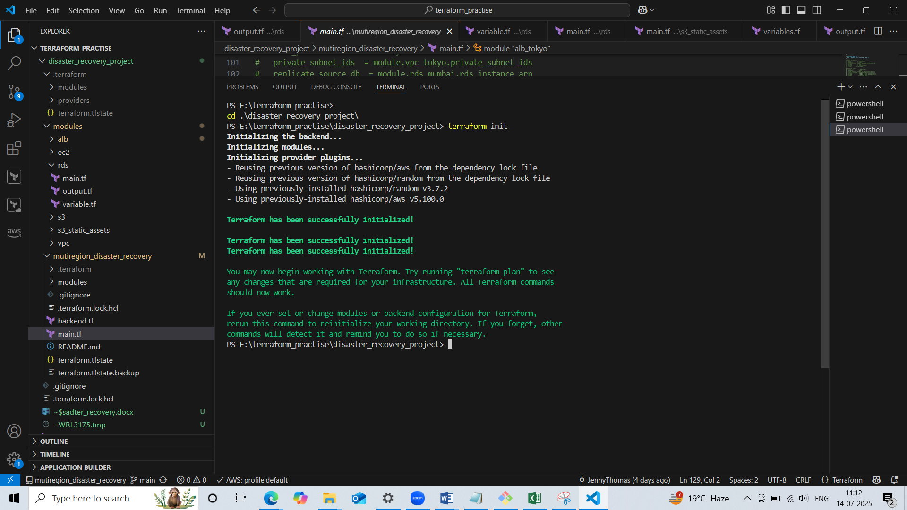

* terraform plan: It connect to AWS and check the current state of your resources. Compare config vs real infrastructure. It tells you what it will **add**, **change**, or **destroy** if you apply it.

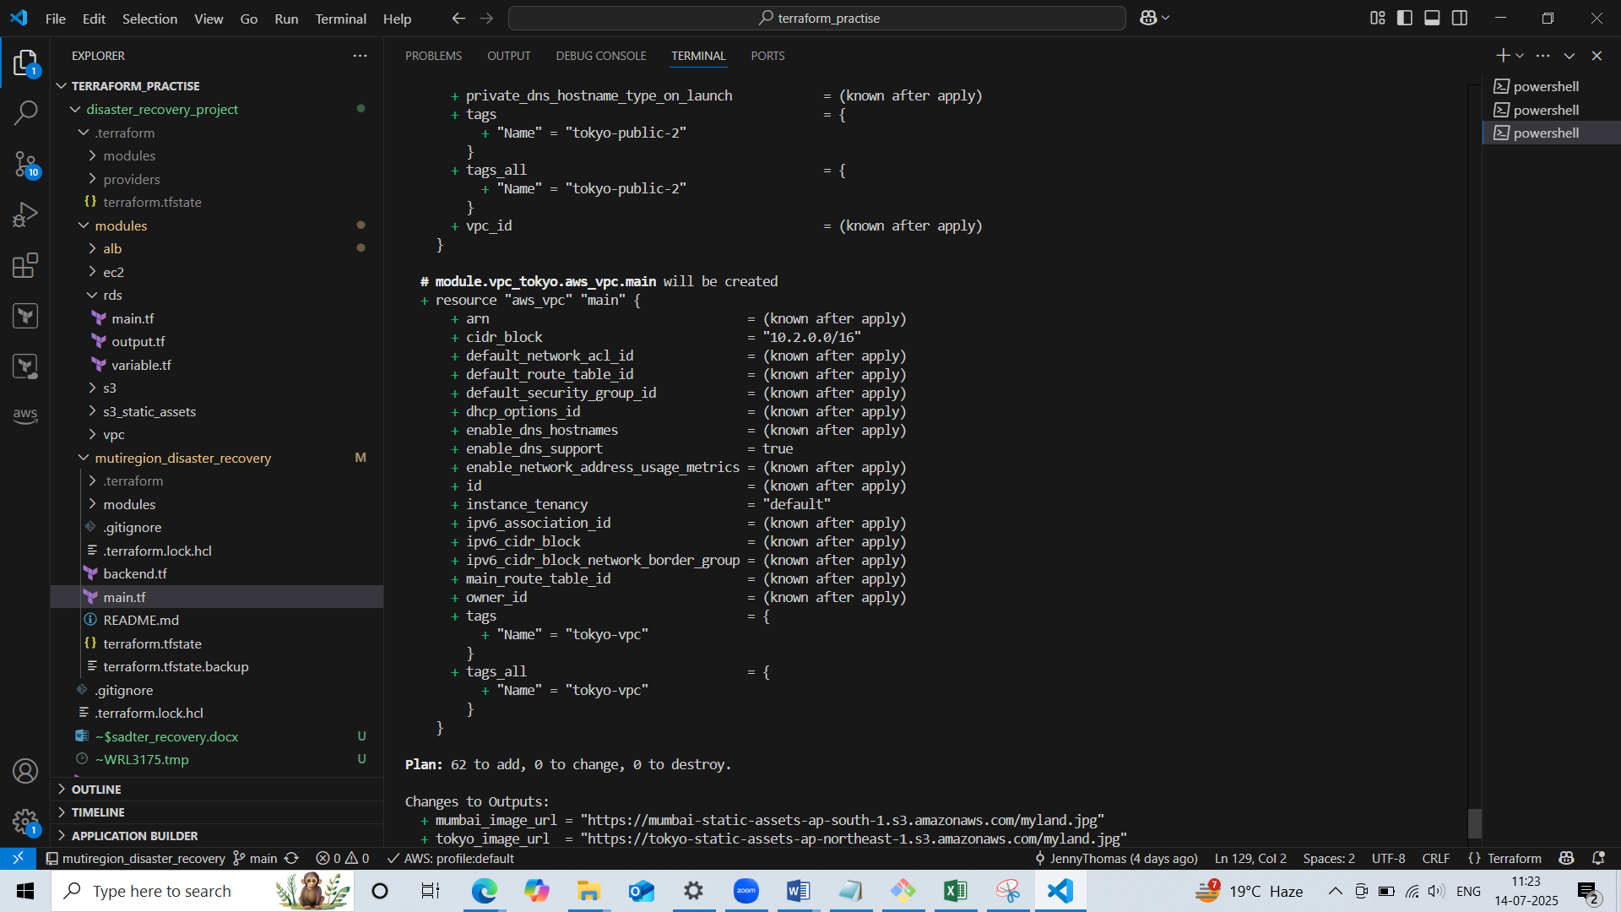

* terraform apply: **Executes** the plan and **provisions, updates, or deletes** resources in your AWS account based on your Terraform code.

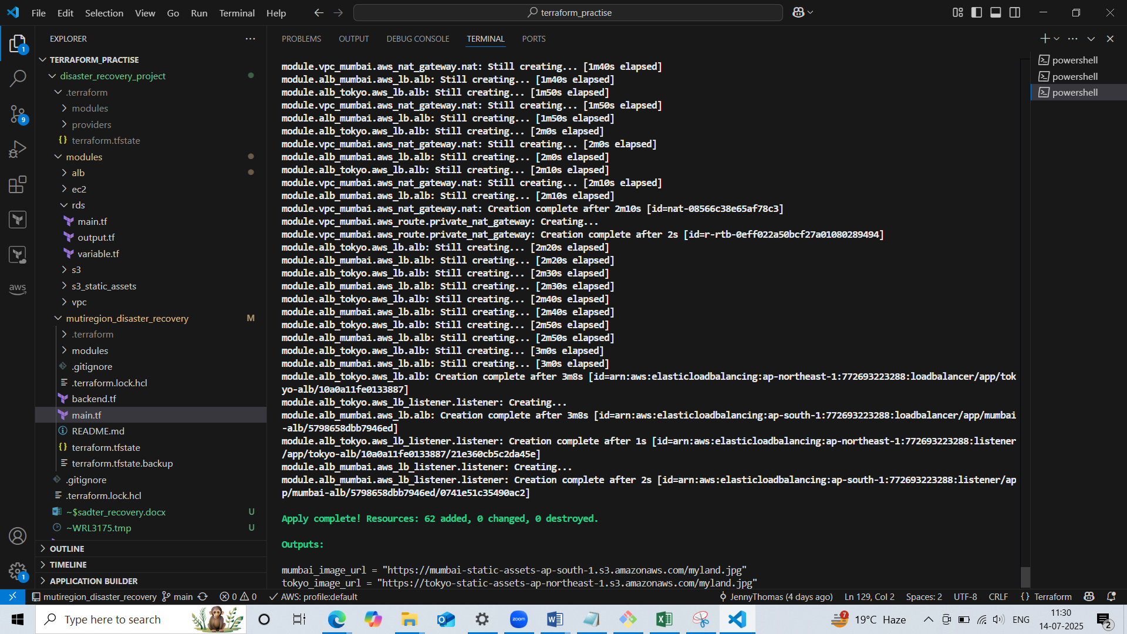

* Now I have created a hosted zone in route 53 where I given the my domain name.jenny.shop which I bought from GoDaddy.
* Created two records for primary and secondary region with failover policy and routing traffic to corresponding load balancer dns.

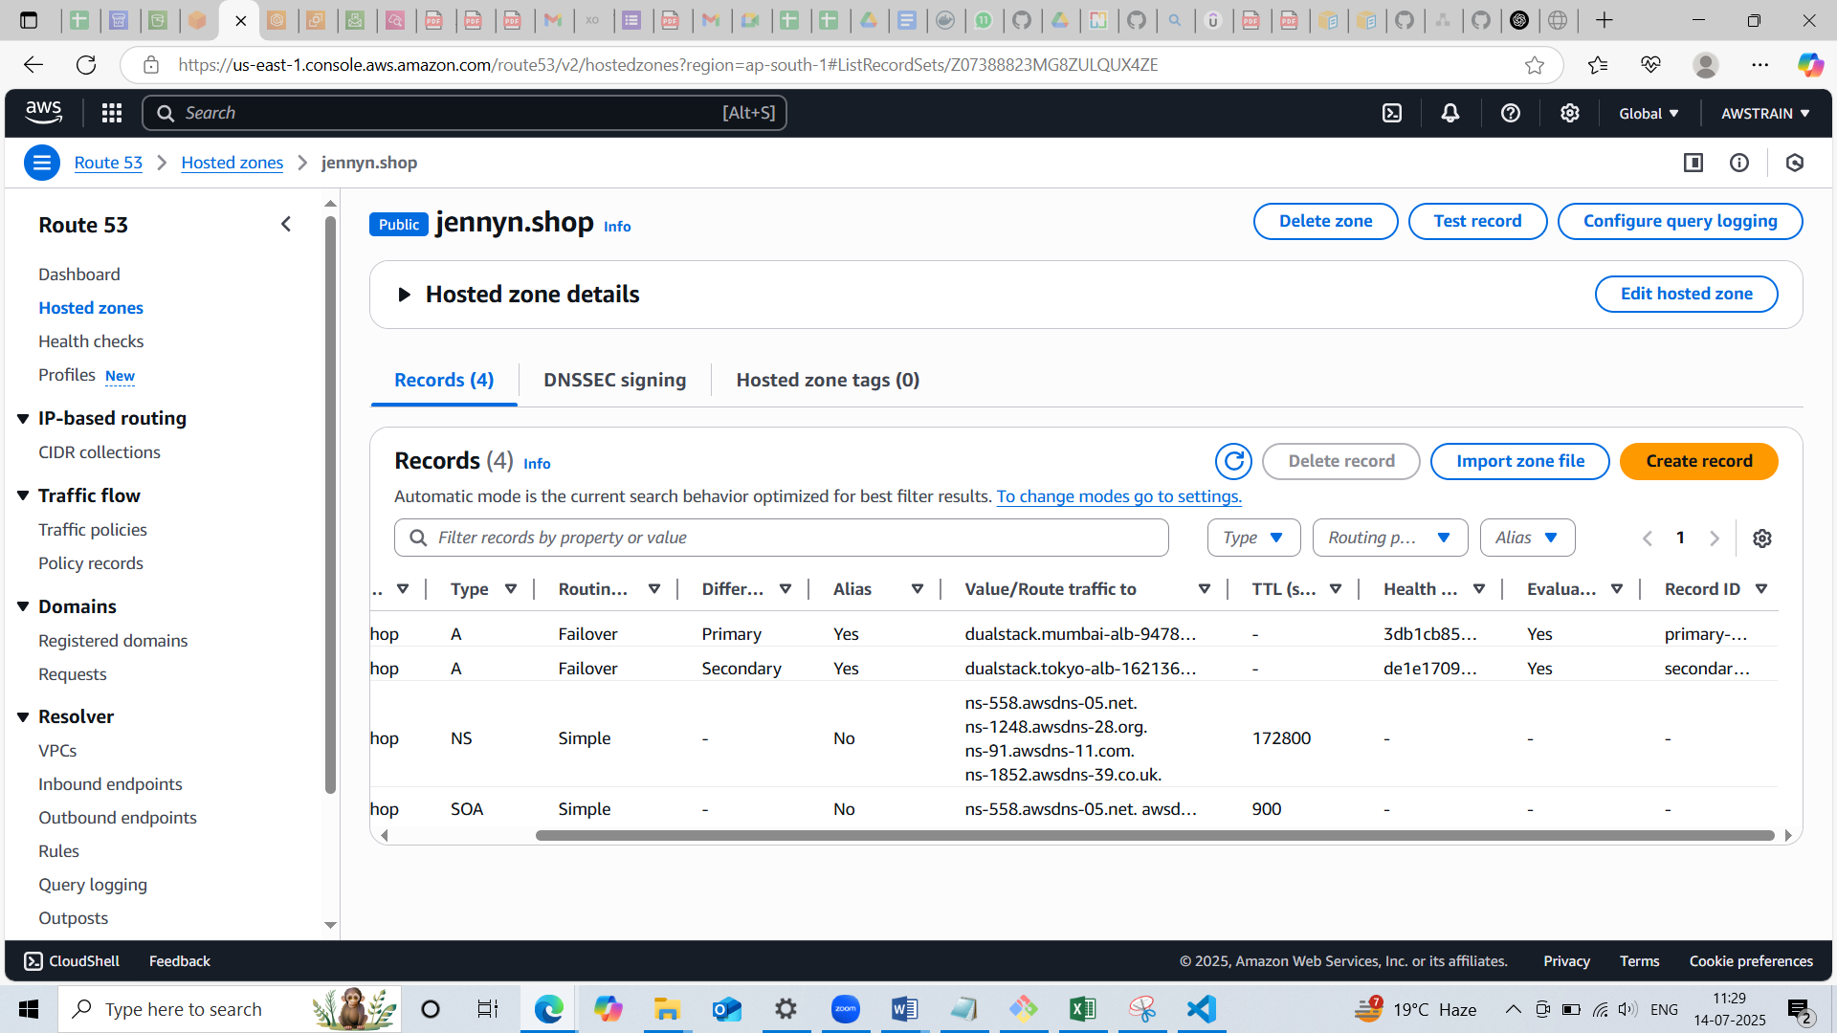

* Also created health check for the records

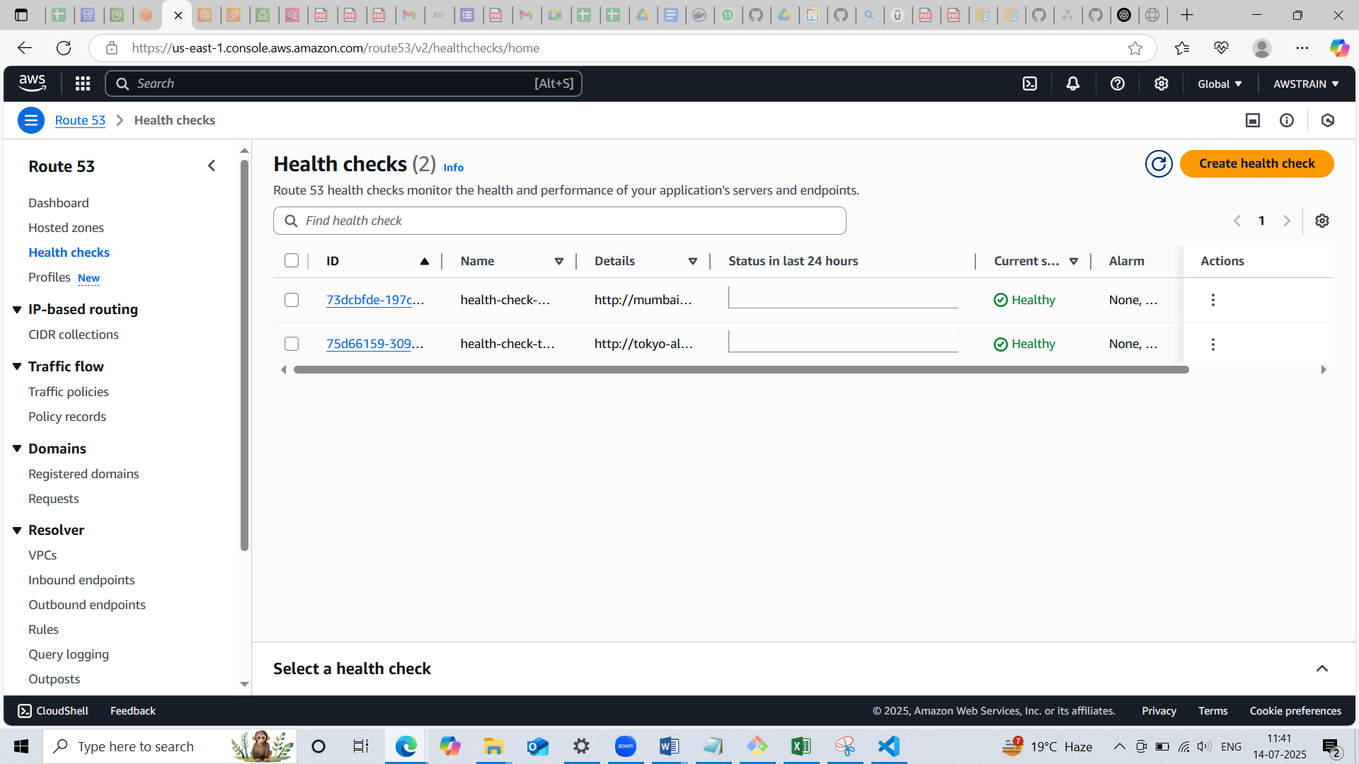

* When accessed the record by the domain, able to access the primary region(mumbai)

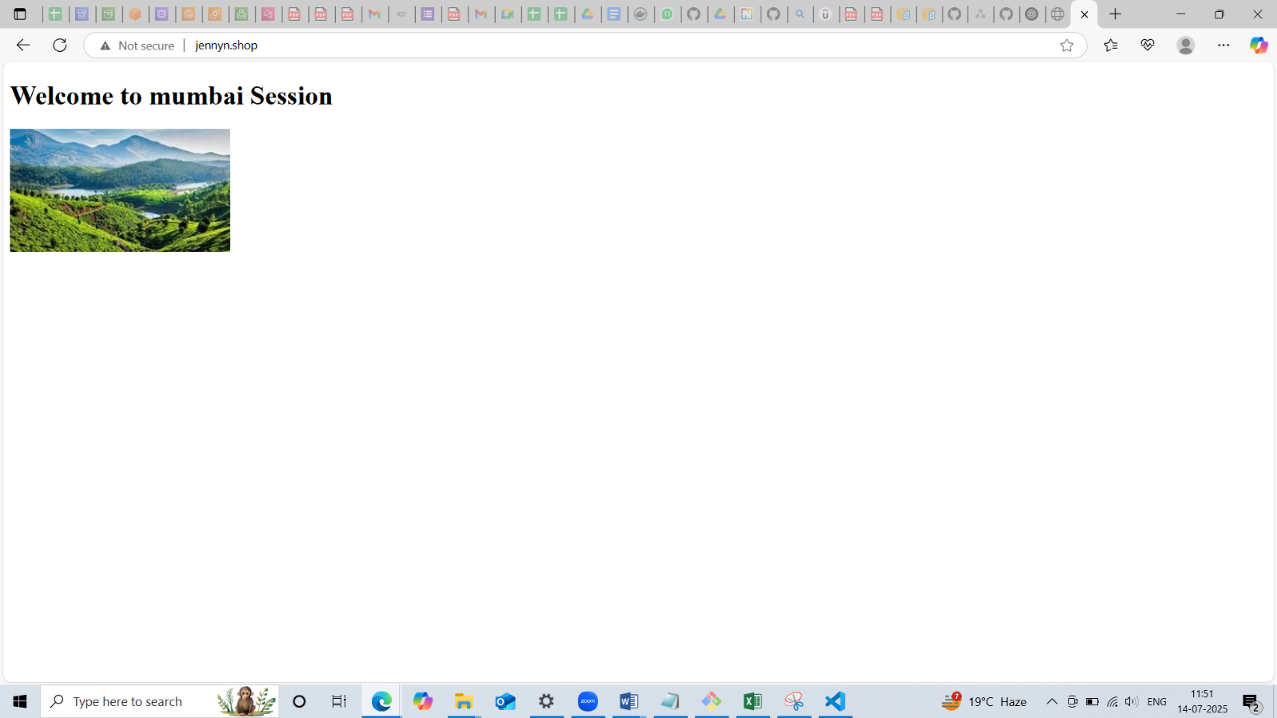

* Then deleted the record for primary region and again checked the domain and was able to access the secondary region(tokyo)

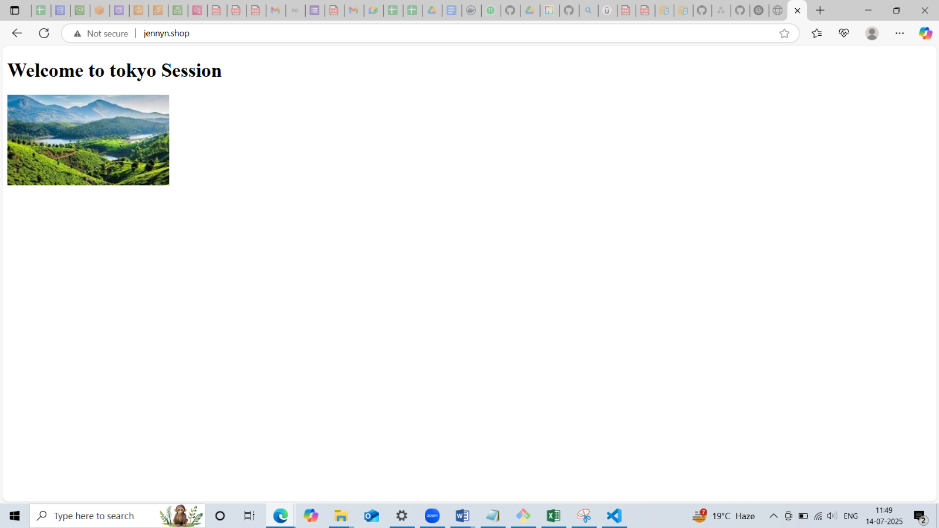

**Architecture:**

